* Image passes through convolution layer
* Mathematical representation:

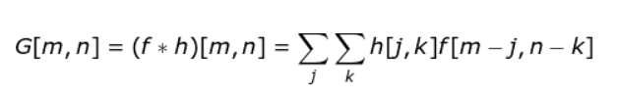

* Conv2d() ->size of filters= 128
* Conv output equation:
  + nout=((nin+2p-f)/s)+1
  + where p=padding,f=width/height